NINCo LMS FAQ Sheet

Self-register to NINCo LMS

- Go to the NINCo LMS website: https://ninco-primaryhealthinsights.talentlms.com/index

- Click on "Sign Up” on the top-right corner of the homepage to create your account.

- Fill in the required details such as your name, email address, and create a password.

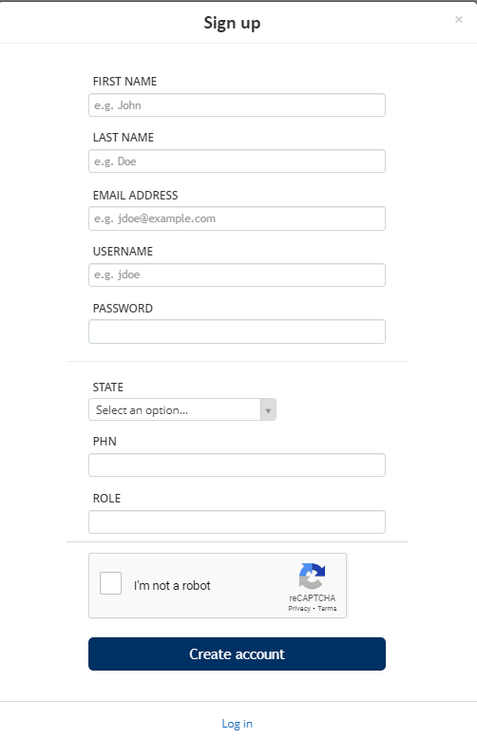
- Click "Create Account" to create your account.

Logging in to NINCo LMS

From the Home Page

- Visit the NINCo LMS home page: https://ninco-primaryhealthinsights.talentlms.com/index

- Click on "Login" at the top-right corner.
- Enter your email address and password.

- Click "Login" to access your NINCo LMS dashboard.

- If you already have user details from a previous login into the other branches on Talent LMS platform you would have to be manually added to the NINCo branch

Using a Direct Link

- If provided with a direct link to NINCo LMS, click on the link.
- Enter your email address and password on the login page.
- Click "Login" to access your account.

Accessing Groups with a Group Key

• After signing up, log in to your NINCo LMS account.  • Navigate to the "Groups" section in the menu. | 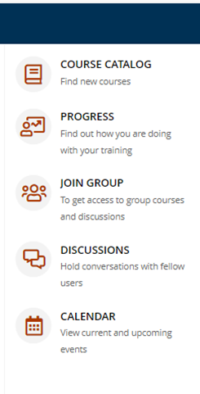
- Click on "Join a Group"  - Enter the group key provided to you  - For Peak Practice – Elevating Healthcare Improvement (online learning modules for quality improvement) the group key is:  NINCo_QI1012024 | 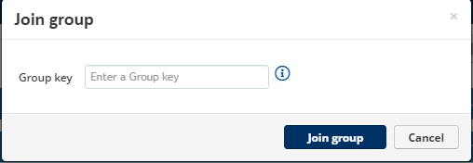
- Click "Join Group" to access the group's content and resources.

- Click "Join Group" to access the group's content and resources.

Reset Password

- Access NINCo LMS Website: https://ninco-primaryhealthinsights.talentlms.com/index
- Click on "Login" at the top-right corner of the page.
- Click on “Forgot Password”
- Enter Email Address
- Enter the email address associated with your NINCo LMS account into the provided field.
- Submit Request.
- You will receive an email from NINCo LMS with instructions on how to reset your password. This email should arrive in your inbox shortly after submitting the request.
- Follow Email Instructions to reset the password
- Login with New Password:

Additional Tips:
- Make sure to choose a strong and secure password for your account.
- If you do not receive the password reset email, check your spam or junk folder.
- If you encounter any issues during the password reset process, you can contact NINCo LMS administrator or support team for assistance.

Contact

- If you need to contact support for NINCo LMS, you can reach out to ninco@gcphn.com.au
- Send an email and provide details about your inquiry or issue, including your account information if applicable.
- NINCo will respond to your email as soon as possible.
- Check the Talent LMS Help Center first for self-service options and answers to common questions.
- By using these support options, you can get timely assistance and solutions to any questions or issues you may encounter while using the LMS.

